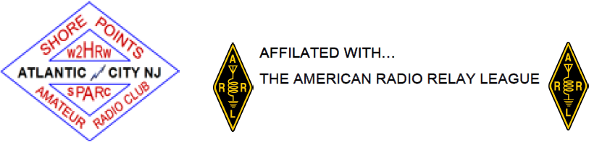

SHORE POINTS AMATEUR RADIO CLUB, INC.

MEMBERSHIP APPLICATION

Name: _________________________________________________________________
Email: _______________________________________ Phone:____________________
Address: _______________________________________________________________
City: _______________________________ State: ______ ZIP Code: ______________
Amateur call sign: _______________ License Class: ________ Exp. Date: ___________
Number of years licensed (optional) : ________
Other Amateur and related organizations you belong to: __________________________
_________________________________________ (Clubs, AMSAT, RACES, ARRL, etc.)
Brief description of Amateur activities: ________________________________________
_______________________________________(Contests, CW, VHF, DX, D-STAR, etc.)
Occupation (brief): _______________________________________________________
Name and call of sponsor (current member): ___________________________________
_______________________________________________________________________
I am applying for:
( ) Full Membership
( ) Associate Membership (unlicensed person)
( ) Family Membership (second licensed person, same household) Call: ____________
( ) Student Membership (per article 3 section 2E of the by-laws)
( ) Provisional Membership (newly licensed Amateurs only)

Dues to be determined by the SPARC Constitution & By-Laws.

If accepted as a member of SPARC, I agree to abide by the rules of the club as set forth in the SPARC Constitution & By-Laws and those of the FCC.

Signature: __________________________________________ Date: _______________

This application is to be presented at a regular meeting by the applicant, or in case the applicant is unable to attend in person due to disability or work schedule, it may be presented by the sponsor.

Membership: Accepted ( ) Rejected ( ) Date: ______________

